Practical Task 0.1

(Pass Task)

Submission deadline: 10:00am Monday, July 25

**General Instructions**

The objective of this task is to ensure you are familiar with the assessment protocols and processes being used this trimester during SIT232 Object‐Oriented Development. You must read this document and complete the form included at the end, submit the form to OnTrack, and have a short introductory discussion with your tutor via OnTrack’s Intelligence Discussion Tool.

**Assessment Model**

SIT232 Object‐Oriented Development has a reputation for being a challenging and enjoyable unit. To help students tailor this unit to achieve the outcomes they are after, SIT232 uses a teaching approach referred to as Constructive Alignment. Constructivism views knowledge as being constructed in the mind of the learner. Therefore, it is important for students to actively perform the required tasks to learn. As a result, the role of the educator changes from someone who “teaches” to someone who “facilitates” learning.

In this unit, this Constructive Alignment is achieved via OnTrack. OnTrack is an in-house developed online software platform that facilitates this formative learning approach via a task‐oriented portfolio assessment. The strategy is to organise learning activities across multiple tasks structured around grade outcomes. You need to select the grade you are aiming to achieve – this decision may be based on your prior experience in the domain, your aptitude towards the topic, your time commitment, or the requirements of your career objective. This selection allows you to scaffold your own learning to achieve greater depth than you previously may have thought was possible.

In general, the graded tasks will provide the following challenge levels:

* **Pass**. This offers scaffolded tasks to help achieve the minimum acceptable standard. Students will be able to implement object-oriented solutions that make use of abstraction, encapsulation, inheritance, and polymorphism if given a detailed design to work from.
* **Credit**. Students will apply what they have learnt in the pass tasks to new problems with less guidance. Students will be able to implement object-oriented designs and propose changes to designs to meet changing requirements.
* **Distinction**. Students will apply their advanced knowledge to design and build solutions to more challenging real-world scenarios. Students will be able to design and develop object-oriented programs to ill-defined problems.
* **High Distinction**. Students will extend their understanding to demonstrate greater technical ability, more complex solution structures, advanced algorithms, or in other ways exceed the expectations of the unit.

For this unit, the following will set the minimum standard for each grade:

* **Pass**: Complete (and **discuss** with the teaching staff) all pass tasks to **guarantee** a pass in this unit.
* **Credit**: Complete all pass and credit tasks.
* **Distinction**: Complete all pass, credit, and distinction tasks.
* **High Distinction**: Complete all pass, credit, distinction, and at least one high distinction task.

Your final grade is based on the number of tasks that you complete at each task level. Students aiming for higher grades will need to succeed with more tasks. It is recommended that you seriously and honestly consider your capabilities. Genuinely advanced students will find pass tasks quick and easy to complete. If you find pass tasks difficult and/or too time-consuming, then you should adjust your expectations. Also, if you do not complete required tasks at a level, we may accept higher grade tasks as a replacement where such tasks suit the requirements.

**Assessment Process**

Knowledge and skills in this unit continuously build on those learnt the weeks before. Therefore, if you fall behind it becomes impossible to understand the subsequent content. Tasks are spread out throughout the trimester and need to be done in sequence and on time. To complete a task, students must follow the formative learning process illustrated in the process diagram below. This is designed to ensure your educators can provide a reasonable level of support to all students.

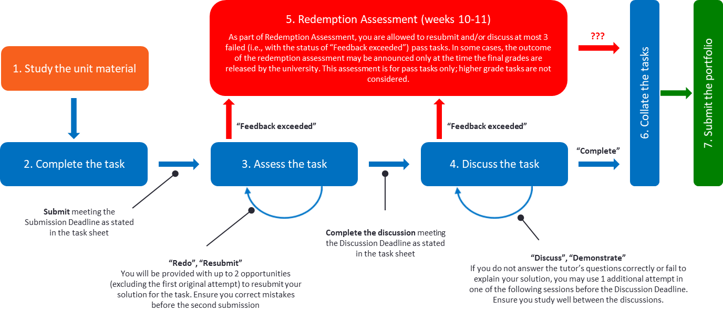

The following describes the steps to be followed during this unit.

1. **Study material**: Ensure you attend/watch lectures and explore the associated unit materials, including the “Further Notes” section of the task sheet.
2. **Complete the task**: During your lecture (lab) time, your lecturer (tutor) will provide some general advice and answer questions to clarify the task’s requirements. They will not provide solutions, but may give you some valuable hints; thus, [attending lectures](https://teams.microsoft.com/l/channel/19%3abd05cbcf1e3a420faed42adf93d2a1a3%40thread.tacv2/Online%2520Classroom?groupId=21448612-ebb2-4664-b89b-83c0456a4213&tenantId=d02378ec-1688-46d5-8540-1c28b5f470f6) and practical sessions regularly is important to get insights on how to solve the assessment tasks. You may also seek peer support by posting questions in the [Online Peer-to-Peer Study Group in MS Teams](https://teams.microsoft.com/l/channel/19%3aa66375ea045947b09cd45ed669d0fa5d%40thread.tacv2/Online%2520Peer-to-Peer%2520Study%2520Group?groupId=21448612-ebb2-4664-b89b-83c0456a4213&tenantId=d02378ec-1688-46d5-8540-1c28b5f470f6) (Click to navigate). Once you believe you have a correct solution, you can submit it via OnTrack (<https://ontrack.deakin.edu.au/>) for assessment.
3. **Get the solution assessed**: Your tutor will check your submission and provide feedback via the OnTrack chat facility. This will either inform you that your solution is correct or will identify where it requires additional work. If it is correct, it will be flagged as “Demonstrate” or “Discuss” and you can go to step 4. If it requires additional work, the tutor will mark the task as either “Redo” or “Resubmit”. You will usually get one additional week to revise your submission to incorporate the tutor’s feedback. Once you are sure you have addressed the tutor’s concerns, you can resubmit. The tutor is only expected to accept **2 resubmissions**. Then, the tutor may decide (i.e., it is up to the tutor’s discretion and is not a must) to give you a day to make minor changes and submit again if on the third submission you are very close to meet the expected standards. If the tutor does not accept your submission, then it will be marked as “Feedback Exceeded”. If a task is marked as “Feedback Exceeded”, you have to proceed to step 5 in weeks 10-11. Plagiarised tasks or purchased solutions will be reported and investigated by the academic integrity committee.

Note that **solutions submitted after the submission deadline** (and thus getting the status of “Time exceeded”) **will not be considered**. If you fail the submission deadline, you fail the task and this reduces the chance to pass the unit. Unless extended for all students, deadlines are strict to guarantee smooth and on-time work throughout the unit.

1. **Discuss (or Demonstrate) the solution**: If your solution has been accepted as correct in step 3, you must also demonstrate to the tutor your individual learning and understanding of the associated concepts through a one-on-one interview. Before the discussion deadline (see the header of the respective task sheet and check the [timetable bookmark in SIT232 MS Teams channel](https://teams.microsoft.com/l/entity/1c256a65-83a6-4b5c-9ccf-78f8afb6f1e8/_djb2_msteams_prefix_2670613932?context=%7B%22subEntityId%22%3Anull%2C%22channelId%22%3A%2219%3Ac7KQLNssKH2Va2XIpNeEcEHE1wlNw80LPs5SgITAfpU1%40thread.tacv2%22%7D&groupId=21448612-ebb2-4664-b89b-83c0456a4213&tenantId=d02378ec-1688-46d5-8540-1c28b5f470f6) for effective extensions), you must either:

* Attend the practical class either via Microsoft Teams (cloud mode) or in person (on-campus mode) and have a one‐on‐one conversation with your tutor. In the former case, ensure you have a working camera and a microphone (Teams has a mobile app available if you do not have a webcam). When you attend the practical class, inform the tutor via a chat message that you are ready for an interview and wait for the tutor to get to you.
* If the task permits, you may record a short video explaining your work and solution to the task. Upload the video to one of accessible resources and refer to it for the purpose of marking. You must provide a working link to the video to the tutor in the respective textbox in OnTrack. A video recording, when it is allowed to replace a live discussion of the task, must be made in the camera on mode; that is, the tutor must see both the presenter and the shared screen. Then, your tutor may record several audio questions. You may use the intelligent discussion facility in OnTrack to answer the additional questions. When you click on these, OnTrack will record your response live. You must answer straight away in your own words. As this is a live response, you should ensure you understand the solution to the task you submitted. If the tutor finds your video recording and/or online explanation unsatisfactory, he/she may still ask you to attend a practical class to pass a one‐on‐one interview.

Questions are likely to cover lecture notes, so attending (or watching) lectures should help you with this **compulsory interview part**. Please, come prepared so that the class time is used efficiently and fairly for all students in it. You should start your interview as soon as possible as if your answers are wrong or incomplete, you may have to pass another interview, still before the deadline. Use available attempts properly. The tutor is only expected to give you **2 opportunities to discuss your task** (including the original attempt). If eventually the tutor does not accept your answers, the task will be marked as “Feedback Exceeded”; see step 5 for the next step.

Again, no solutions will be generally discussed after the discussion deadline. Uncompleted solutions will be marked as “Feedback Exceeded”. If you fail the deadline, you fail the task and this reduces the chance to pass the unit. Unless extended for all students, the deadlines are strict.

If the tutor is satisfied with your answers, the task will be marked as “Complete”.

1. **Redemption assessment**: If your pass task is marked as “Feedback Exceeded” or “Time Exceeded” (assuming that the first submission is made before the submission deadline), you can still obtain a pass in the unit by passing an additional assessment for this task during the weeks 10 and 11. This option is only provided for pass tasks. If the redemption assessment is possible, your tutor will indicate this via a comment in the chat box in OnTrack. The redemption assessment can have different forms and depends on your particular situation; this will be decided by your tutor and the unit chair case by case. You can be given an additional opportunity to discuss the failed tasks or may need to pass a special interview covering the topics related to such tasks. In the latter case, all further video communications will be recorded for a reference and the outcome will be announced only with the final grade for the unit. You will be allowed to pass this assessment for **no more than 3 failed pass tasks** regardless the total number of failed tasks.
2. **Collate all tasks**: At the end of week 11, you will need to prepare your final portfolio for submission. This will involve filling in a cover sheet, indicating the number of tasks you have completed at each level, and justifying the learning that you have accomplished. The aim of this is to complete a self-reflection on your study and argue for the grade you believe you should receive.

**Submission of This Task**

Having read the above discussion, this task requires you to complete the following form and submit it to OnTrack. Once submitted, your tutor will initiate an Intelligent Discussion with you which you will need to provide a response. This discussion will only be asking you to introduce yourself to the tutor. If this pre-pass task is not completed, we will not be accepting any future task submissions.

Student ID: 220325142

Name: Lachlan Mackie Robinson



🞎 Tick to indicate you have read this task sheet, asked your tutor anything you need clarified, and that you understand what you need to do to pass this unit.



Signed:

Date: 11-07-2022